Canadian Habesha Cofffee Company
Our Clothing Line
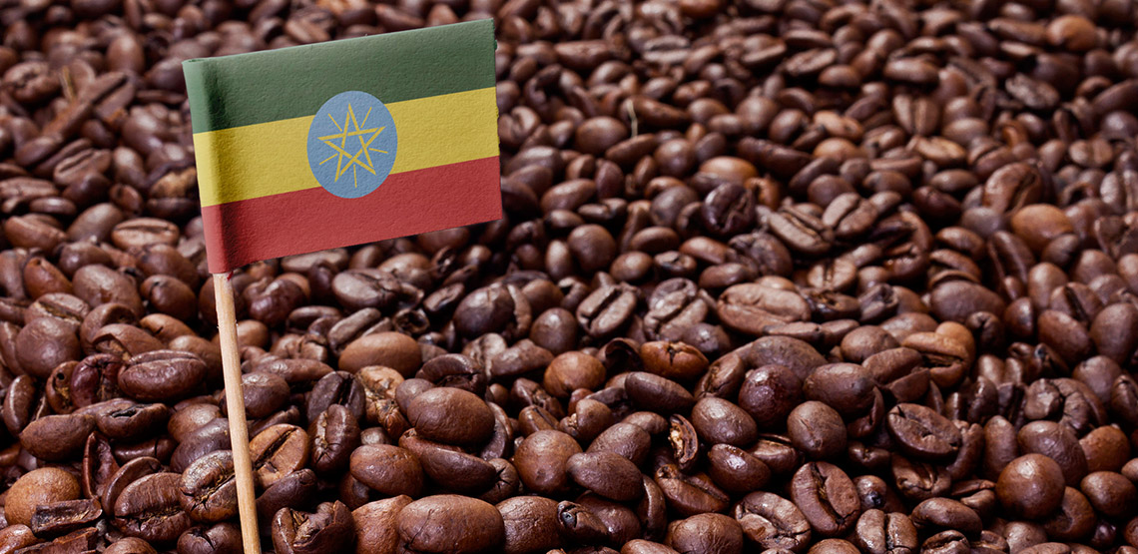
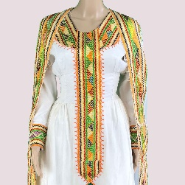
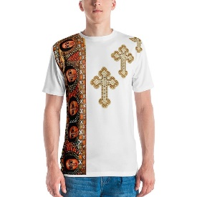
Ladies Habesha Kemis Men’s Habesha Shirt
Sizes: S,M,L,XL, XL2 Sizes: S,M,L,XL,XL2
$ 49 $25
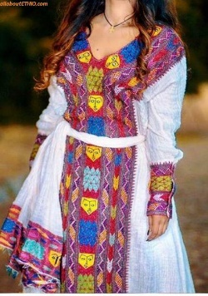 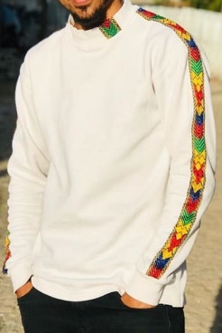
Ladies Habesha Kemis Men’s Habesha Shirt
Sizes: S,M,L,XL, XL2 Sizes: S,M,L,XL, XL2
$ 55 $30
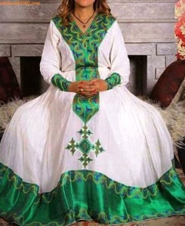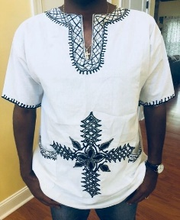
Ladies Habesha Kemis Men’s Habesha Shirt
Sizes: S,M,L,XL, XL2 Sizes: S,M,L,XL,2XL
$65 $35 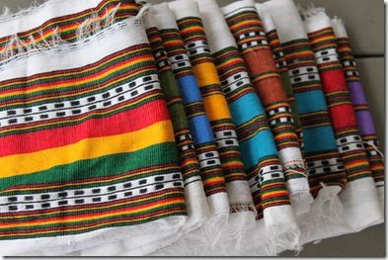 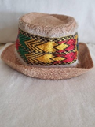
Ladies Scarf (Netla) Men’s Habesha Hat
Colors: Red,Blue,Orange Sizes: S,M,L
Traditional Ethiopian $15
$15

