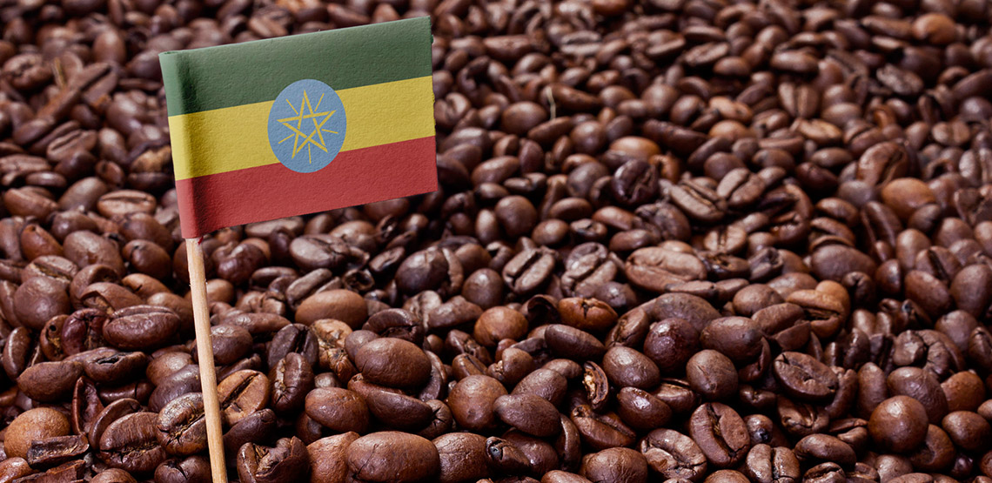 |  | Canadian Habesha Coffee Company  Grinders, brewers, and coffee kits
Keurig K-cup countertop brewer. This countertop Keurig K-cup brewer is a high quality machine with a slide out tray that holds 20 of your favorite k-cup pods.

$75
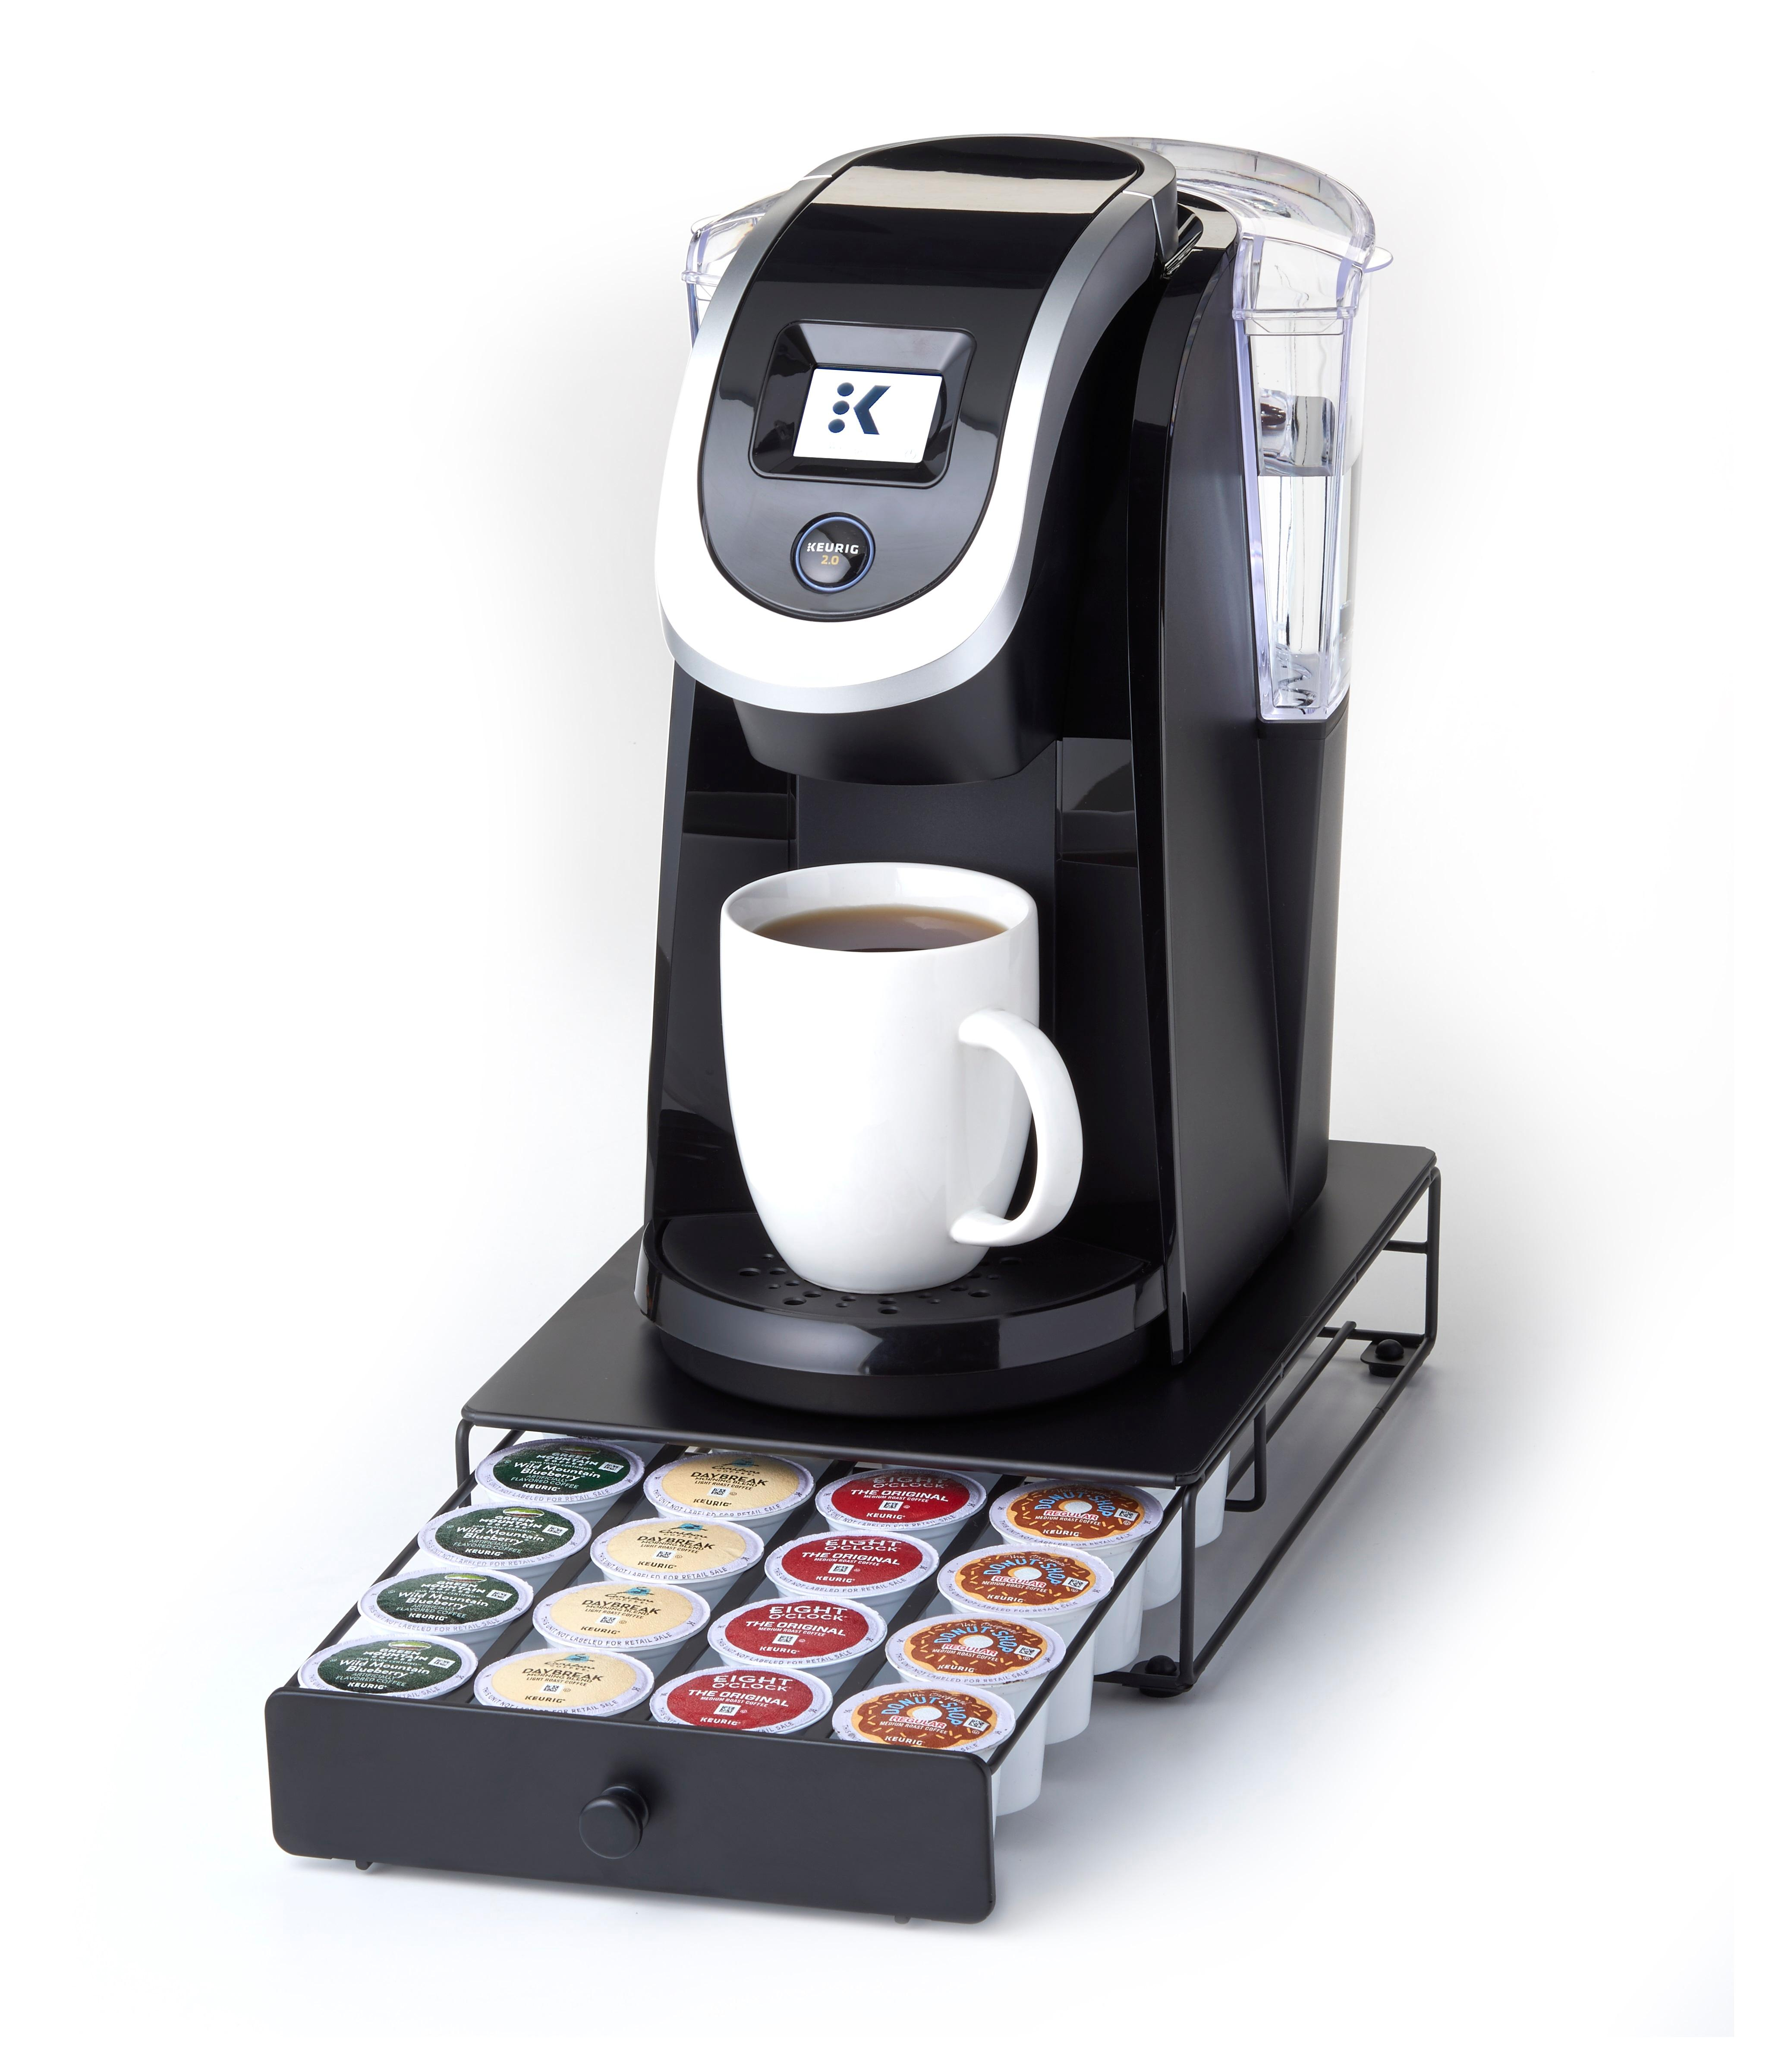

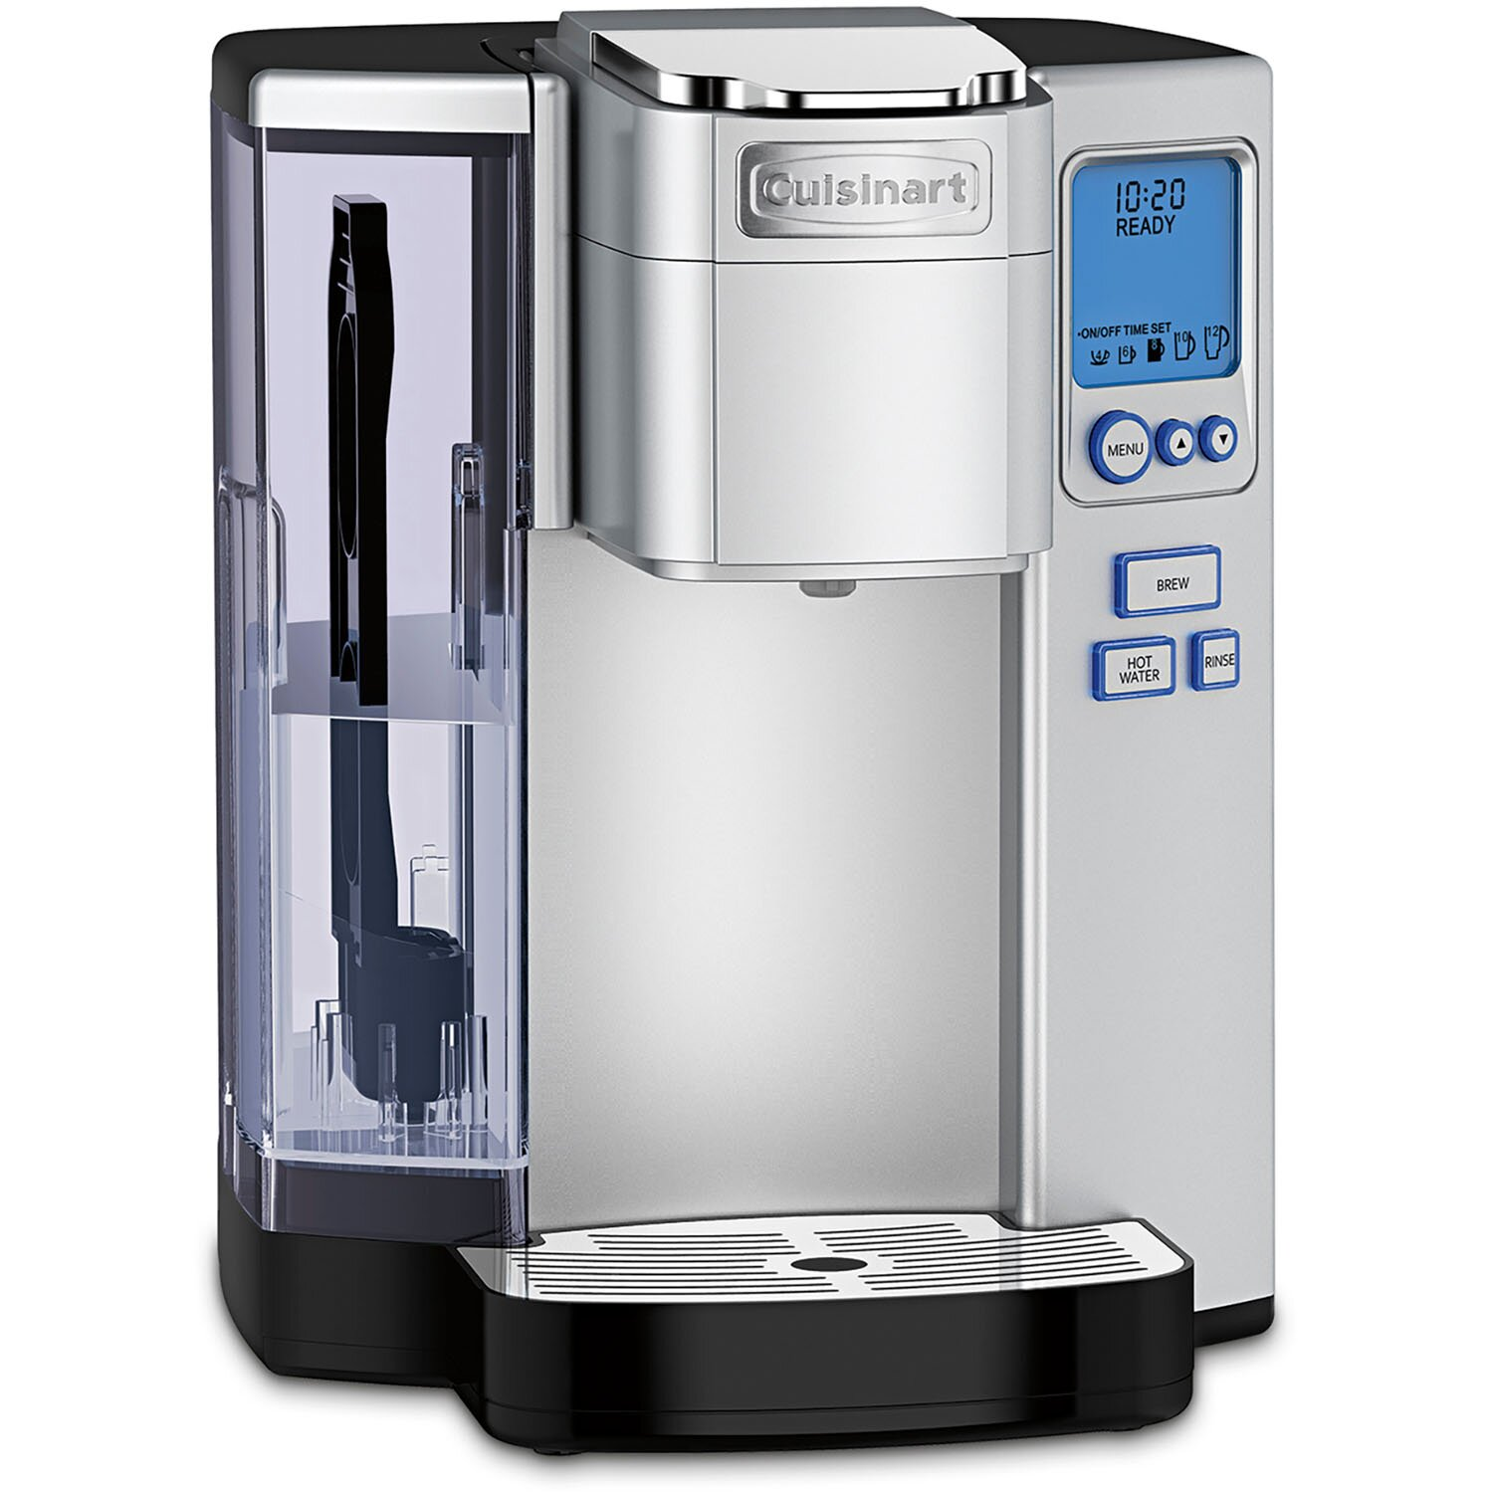

Cusinart universal pod style coffee brewer. This brushed stainless steel coffee brewer is designed to use all the common coffee pods such as the K-cup, Nespresso pods, Mellita, and Lucaffe ESE Espresso Pods. The reservoir holds 2 liters of water so you won’t run out between cups of your favorite brew.
$90

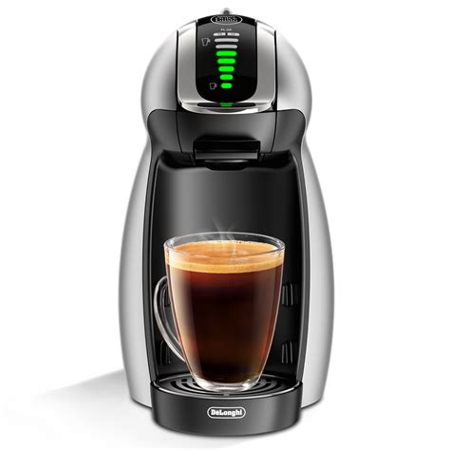

This DeLonghi individual coffee brewer is the designed to use the Nespresso pods. It is the perfect size for small countertops, and it’s easy to use features let you choose the right brew for your coffee.

$82

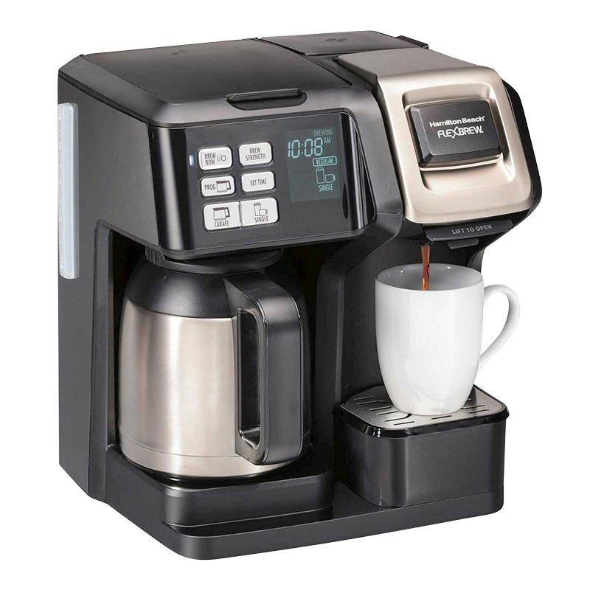

Combination drip and K-cup coffee brewer. This programable combination drip coffee brewer also brews individual k-cups, and has a stainless carafe that holds 4 cups of coffee.

$69

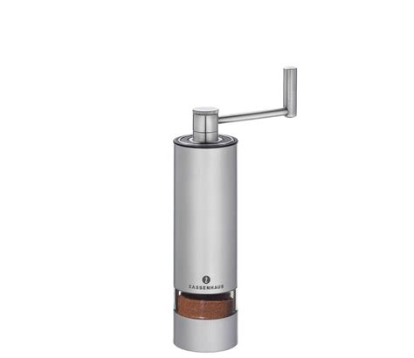
This aluminum coffee grinder is the perfect size to grind individual servings of fresh coffee. The internal gears are hardened stainless steel for years of dependable service, and the glass sight window lets you know when your coffee is the perfect grind.

$50

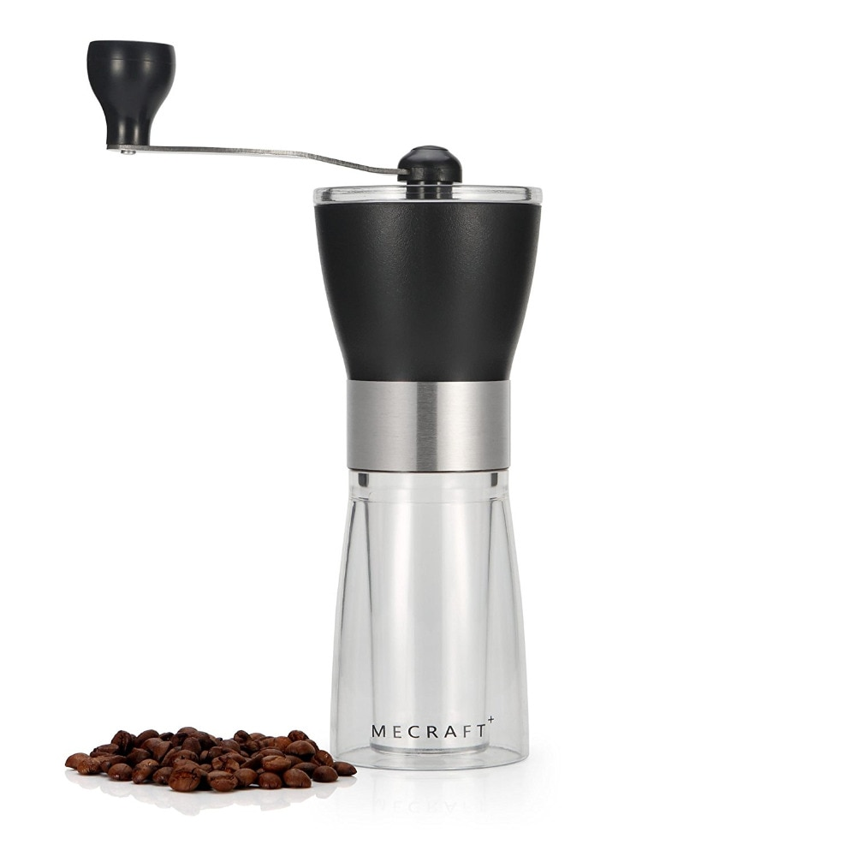

Hand cranked coffee grinder. This plastic coffee grinder is the perfect size to grind your special blend of coffee. The size of the grind can be adjusted by the thumb screw on the handle.
$30

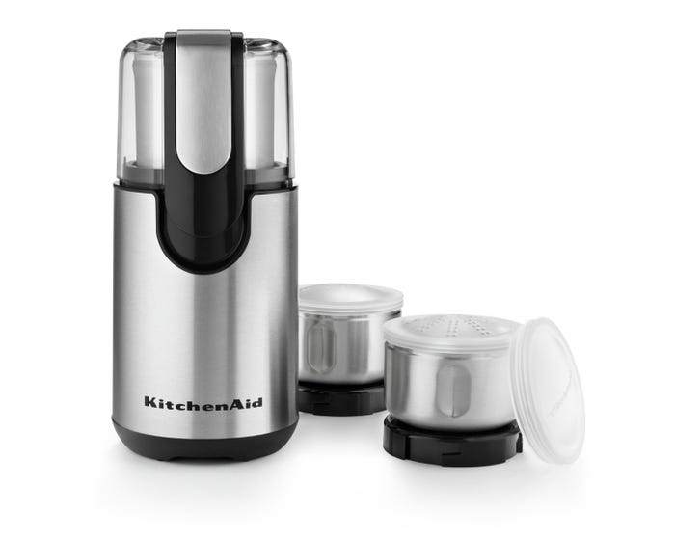

Stainless steel electric coffee grinder with 2 extra cups. This Kitchenaid coffee grinder will give you years of dependable service. The 2 extra coffee cups let you store extra ground coffee in a sealed container that you can use for your next pot of coffee.
$65

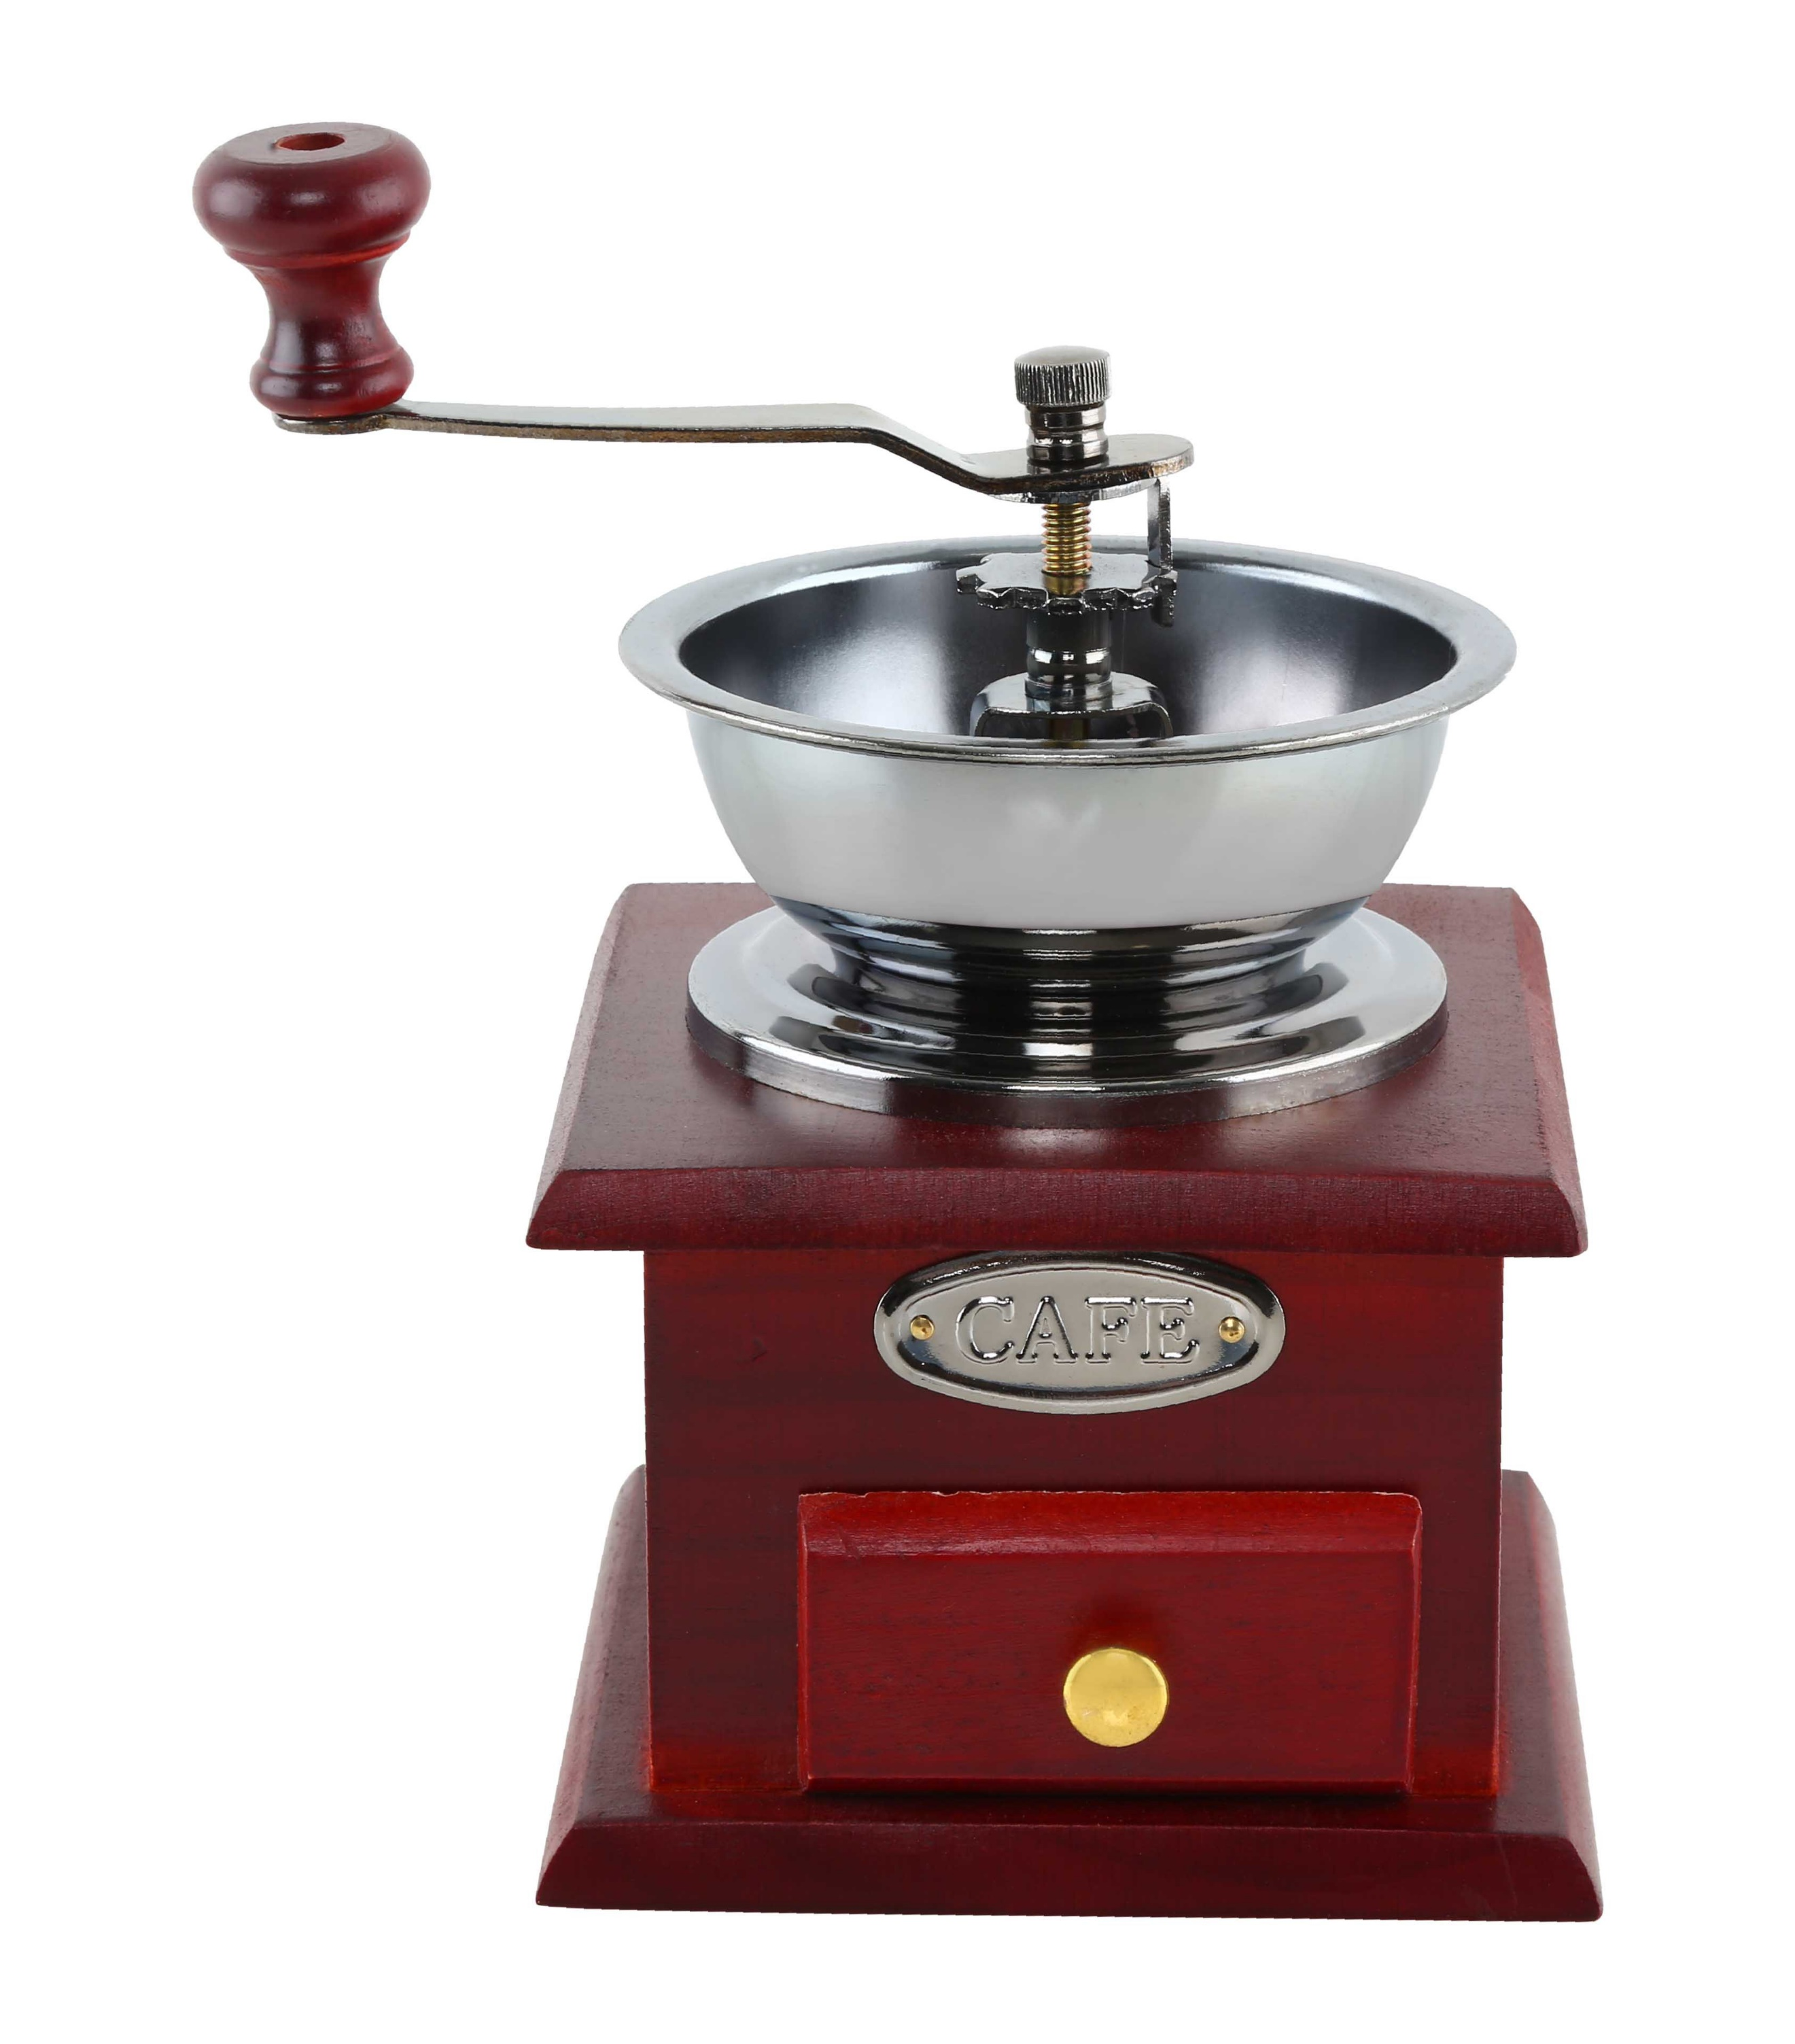

This handmade wooden and stainless coffee grinder is sure to be a centerpiece of your coffee table. The gears are made from hardened stainless, and the stainless steel bowl is large enough to hold 1/8th of a pound of coffee beans.
$55

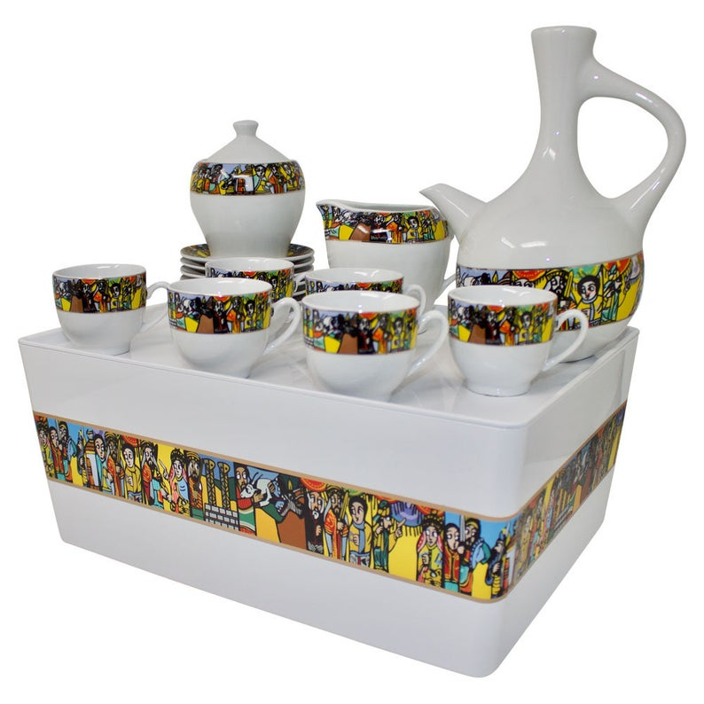
Hand painted ceramic coffee ceremony set. This beautiful hand painted ceramic coffee ceremony rekebot has traditional air painted on the sides and each ceramic piece. This 6 place setting rekebot comes with 6 cups, saucers, sugar dish, and ceramic jebena.

$60

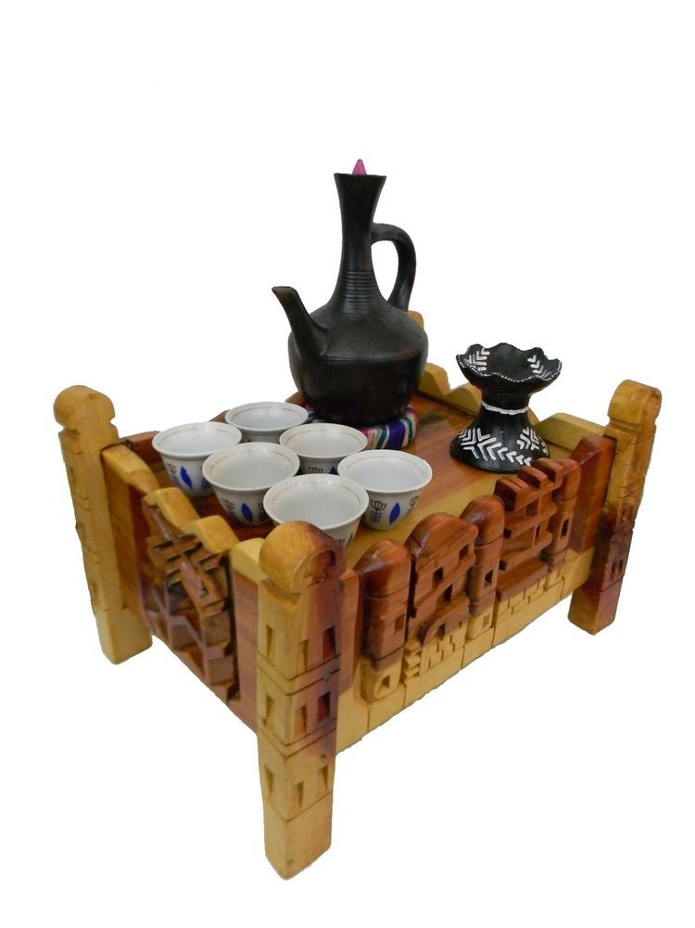
Traditional hand carved wooden Rekebot with clay Jebena and charcoal incense burner comes complete with 6 hand painted ceramic coffee cups.
This coffee ceremony set will be a conversation piece. The hand carved wooden rekebot has carved reliefs of historic Ethiopian buildings from Axum, Lalibela, and Gondar.

$60

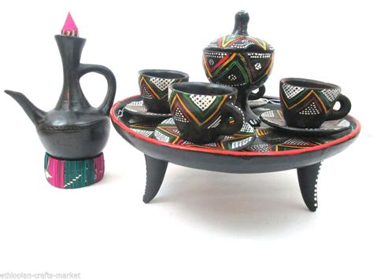
Clay Coffee Ceremony set. This 3 setting Coffee Ceremony set comes with hand painted clay Jebena, 3 clay coffee cups, a hand painted sugar dish, and clay serving table.
$35

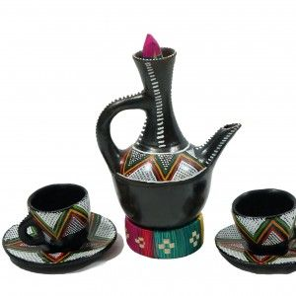
Clay Jebena with 2 clay cups. This hand painted and crafted Jebena is the perfect addition to your coffee ceremony set. It comes with woven stand and wooden topper.
$20

Habesha printed coffee cup. These coffee cups and saucers have a traditional Habesha imprint on the rim. They come in sets of 4.
$18 set of 4
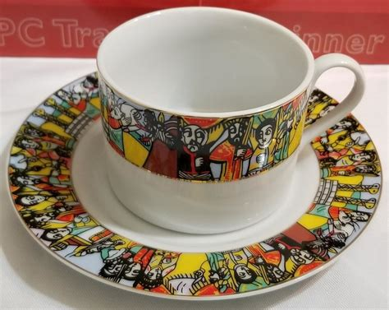

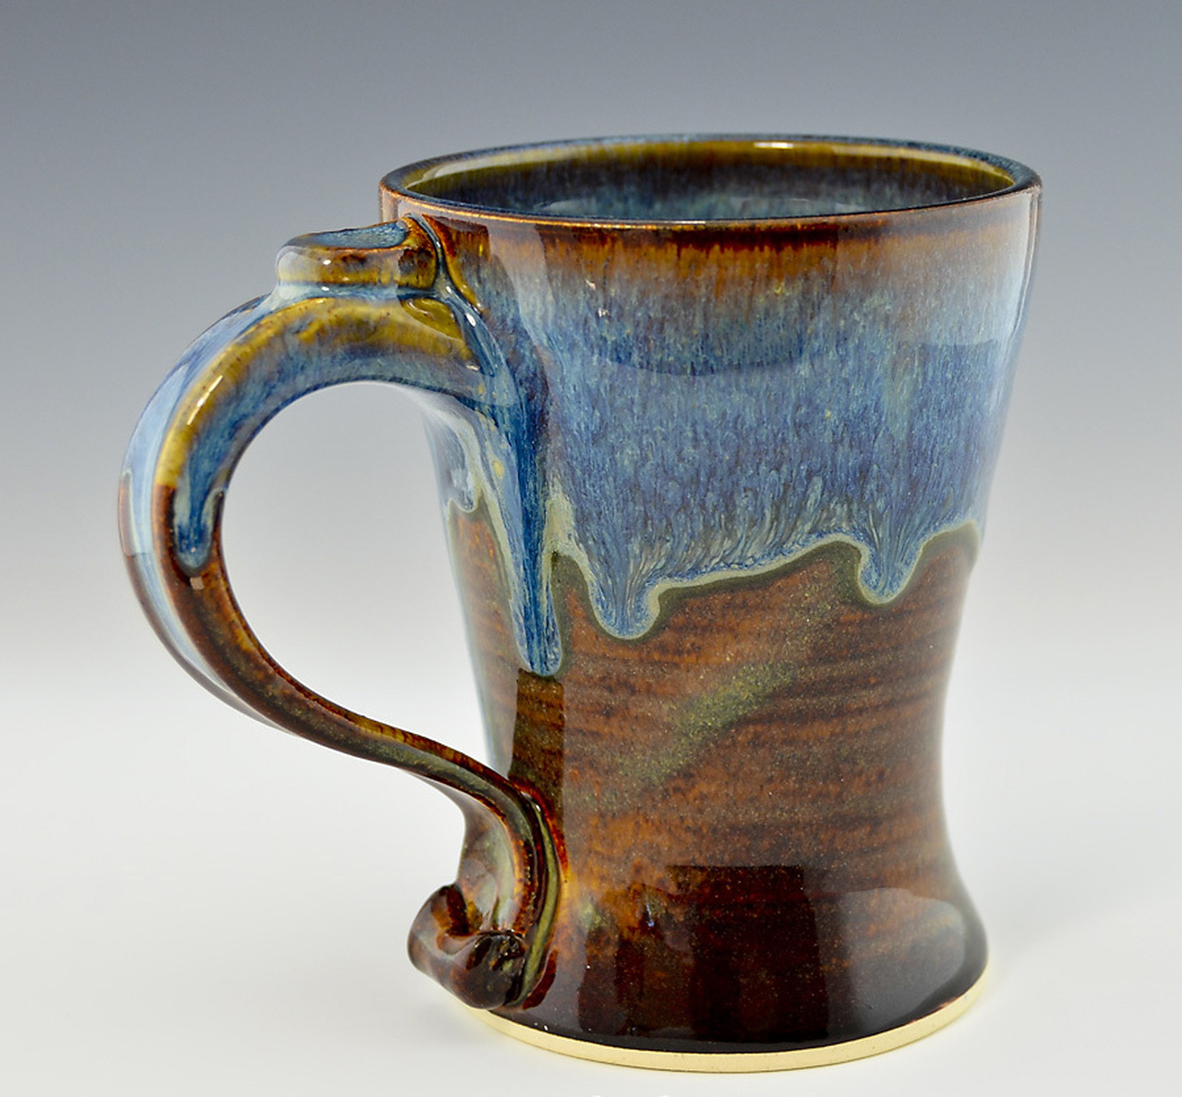
Hand crafted ceramic coffee mug. Each one of these coffee mugs is individual hand crafted. They make a great gift, and can be purchased individually or in any quantity you choose.
$6 each

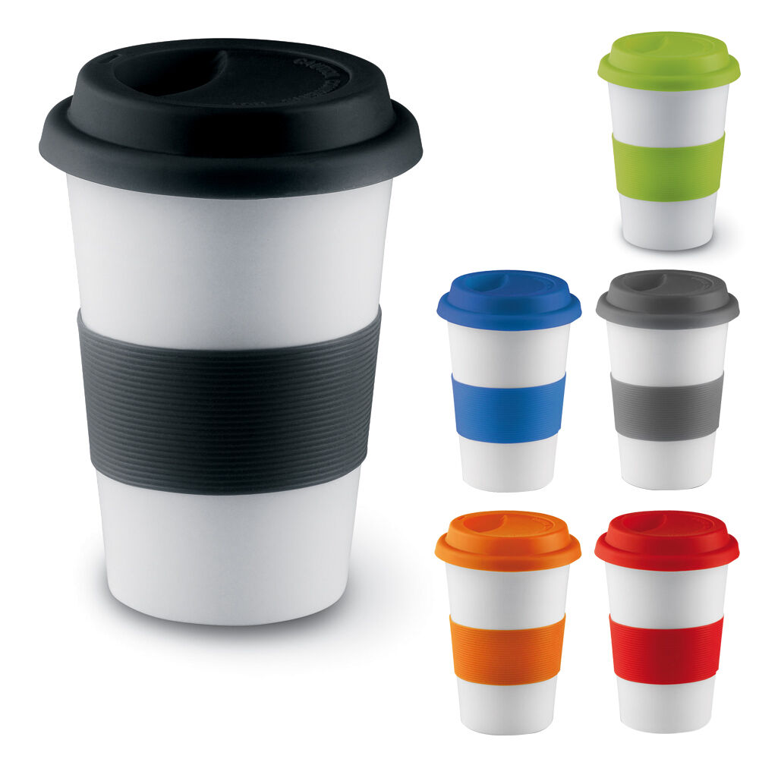
Thermally insulated travel cup with silicone lid. These thermally insulated travel mugs are a great way to take your coffee on the go. They come with a tight-fitting silicone lid that is guaranteed not to pop off at the wrong moment.
Your choice of color.

$8 each

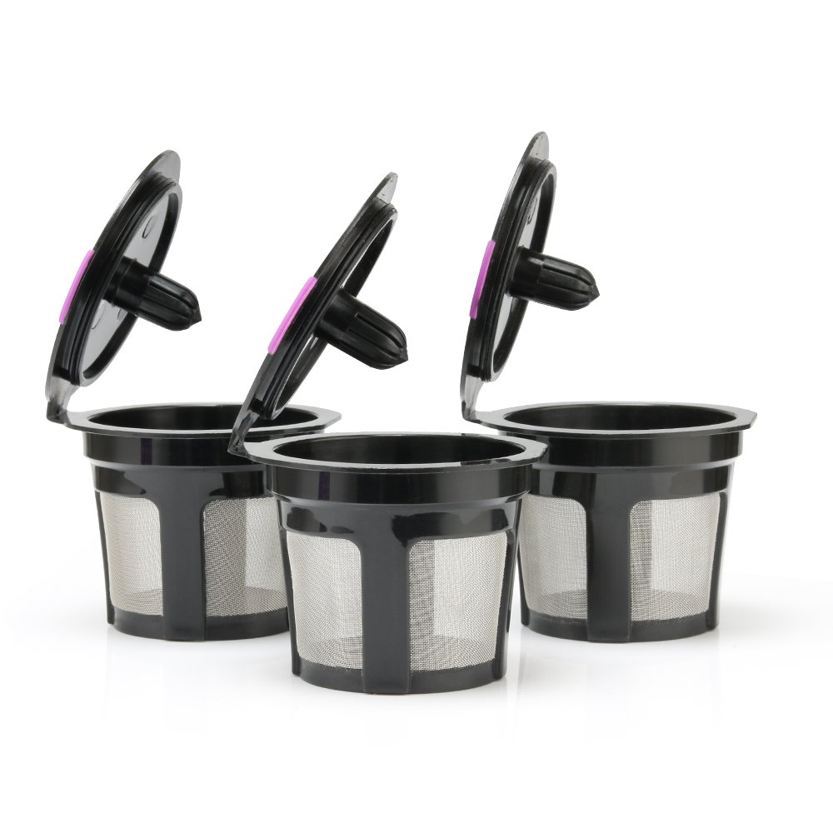
Reusable K-cup pods. These cleanable and reusable stainless steel mesh K-cup pods are a great way to enjoy your own ground coffee. Just place your ground coffee in the pod, and use the same as a regular K-cup. Comes in 3 piece set.
$10
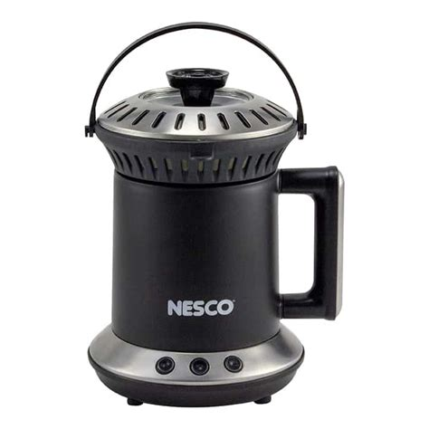

This modern charcoal coffee roaster. This charcoal coffee roaster is designed to stay cool to the touch. It is the perfect burner to take on camping trips so you can roast your own coffee.

$35

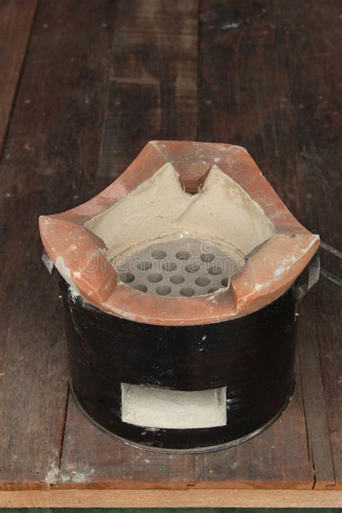

Traditional Ethiopian clay charcoal pot. This clay pot is used to roast coffee for the Coffee Ceremony and is also used to cook traditional food. It has an air inlet and once the coal is set alight, it will quickly provide an even and consistent burn of the charcoal.

$25

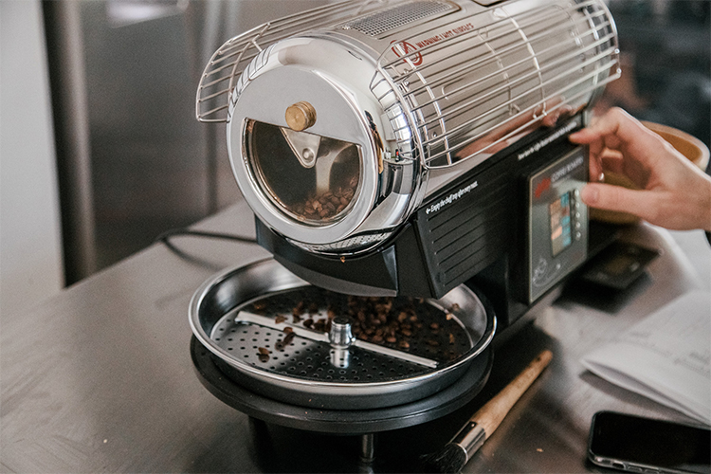
Countertop drum coffee roaster. This coffee roster is programable to ensure each roast is consistent. It contains a timer and will shut off after the programmed time. Capacity is ¼ pounds of coffee beans.

$50

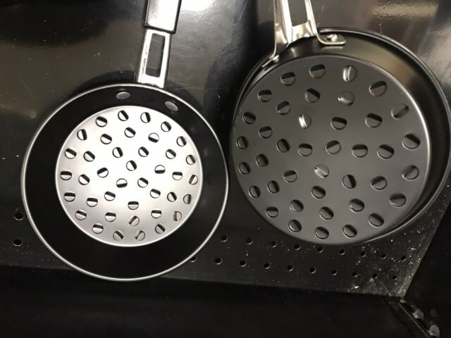

Traditional steel Mankeshkesha. This pot is used to roast coffee over open fire or charcoal. It is a must have for your Ethiopian Coffee Ceremony.

$10

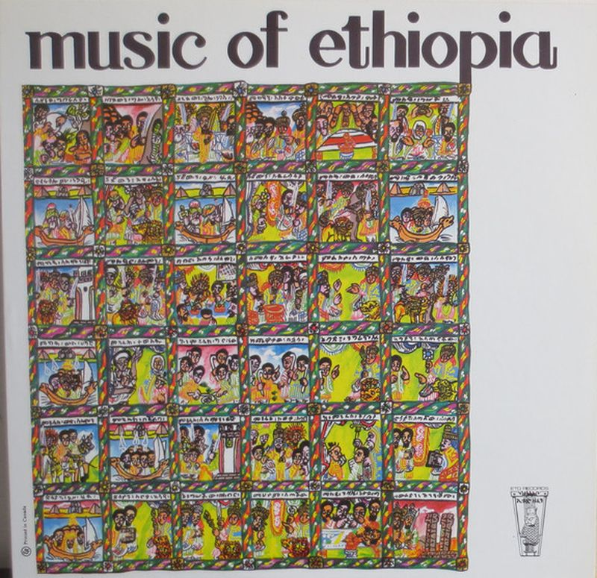
This DVD of traditional Ethiopian music videos is the only music disc you need. This disc has music videos from all regions of Ethiopia and includes all the famous songs and dances from each region. Also included in this disc is the Ethiopian Coffee Ceremony.
$10

