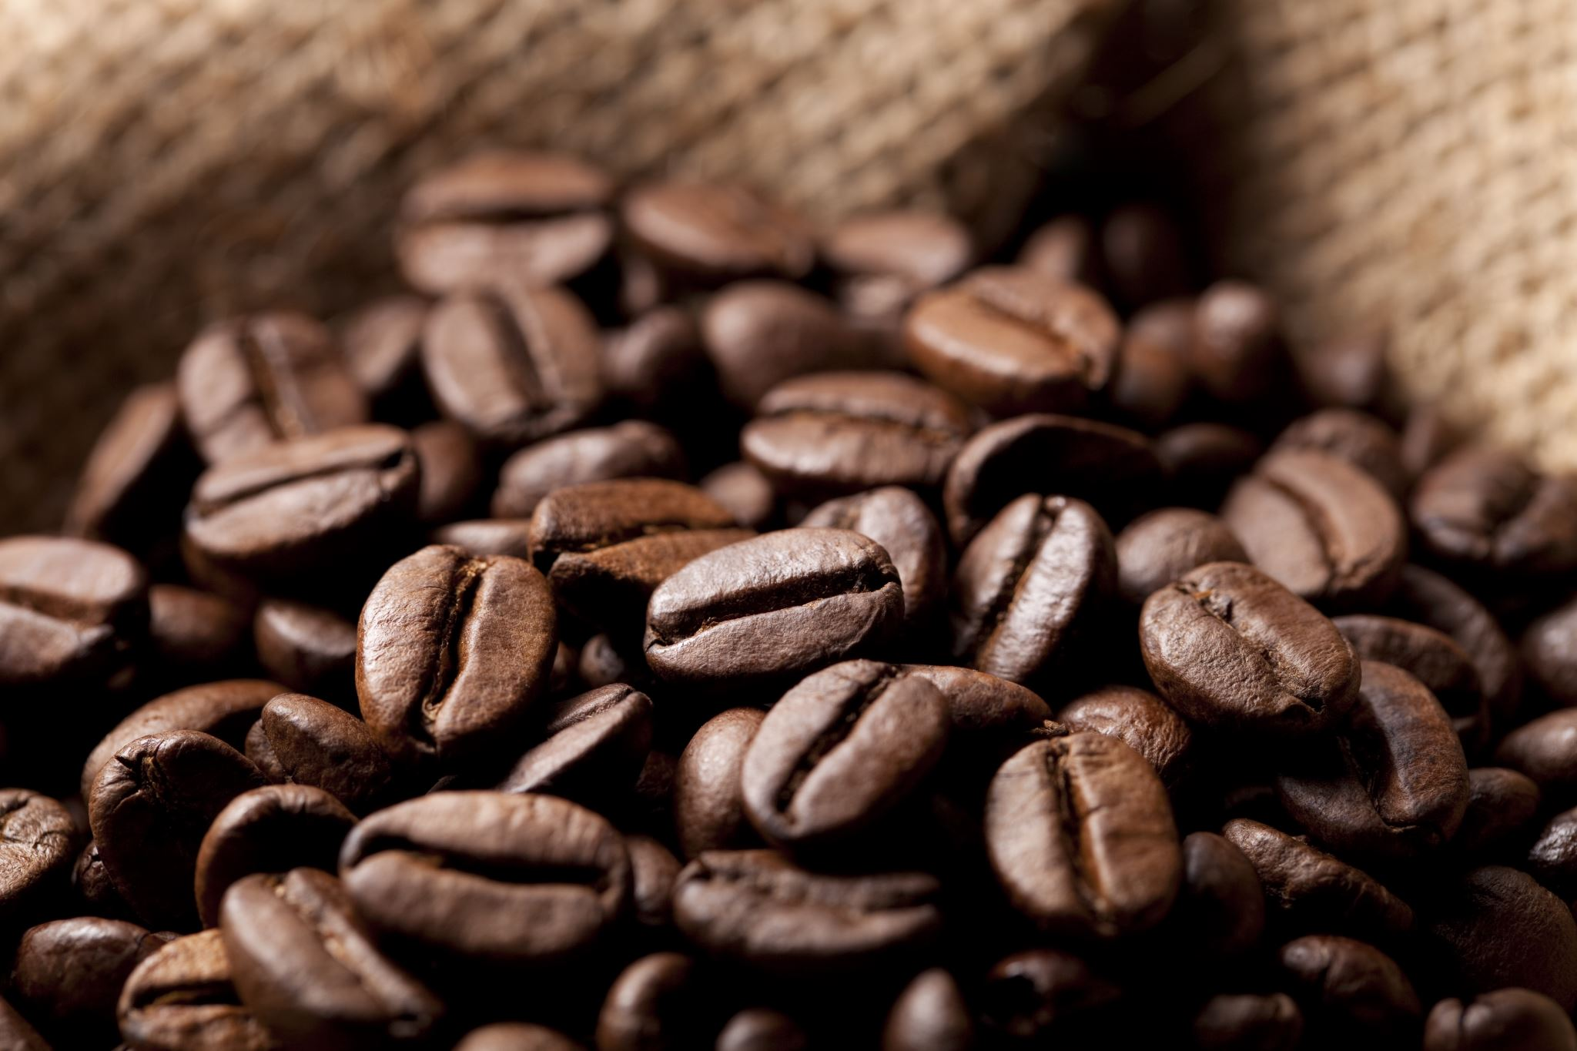

100% organic Coffee
At the Canadian Habesha Coffee Company, we only source the best coffee beans grown 100% all naturally and ethically produced, directly from the grower to our buyers, then shipped to our roasting facility in Canada. You know you are getting the best organic coffee available when you choose the Canadian Habesha Coffee Company.

100% of our coffee is grown locally in the various regions of Ethiopia. We have dedicated farmers who grow our coffee the same way it has been grown for centuries. Natural sunshine, rain from mother nature, and picked by hand. You can't get a better bean, and you know each bean that we use has been grown and picked with care.

 |  |  | The Canadian Habesha Coffee Company
 |  | 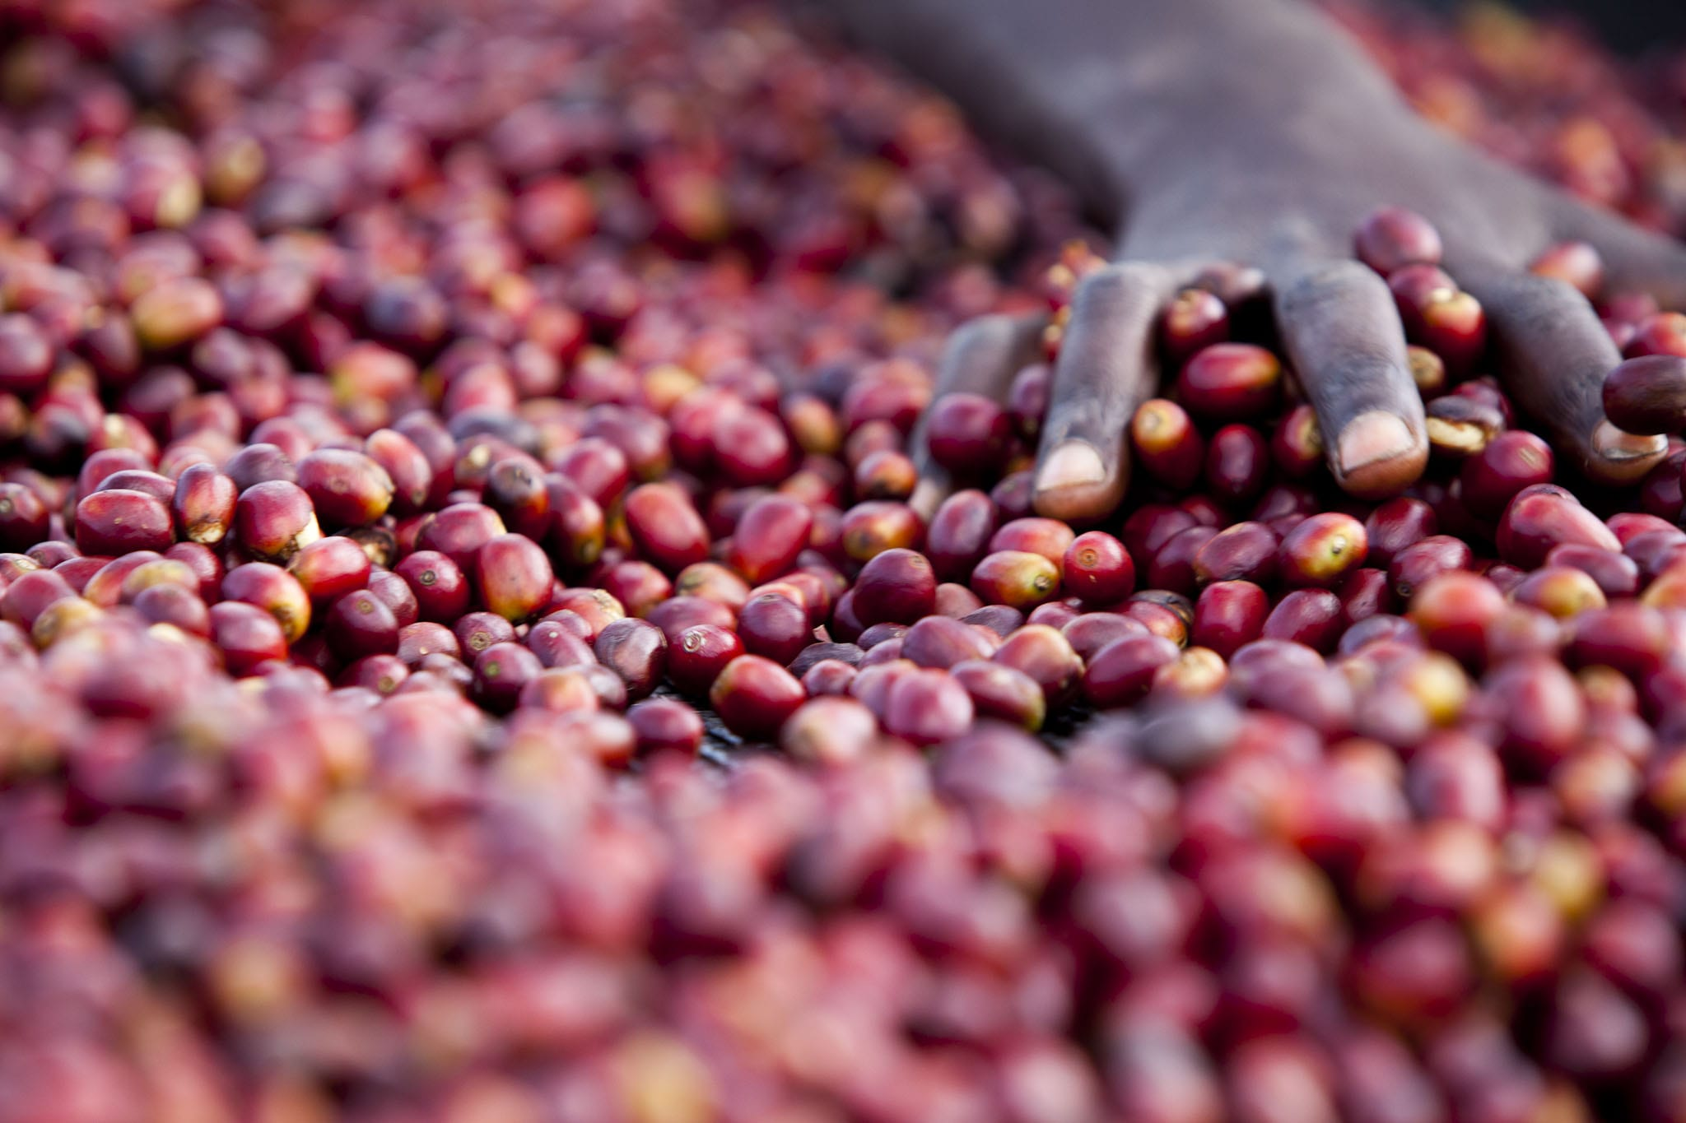 |  | 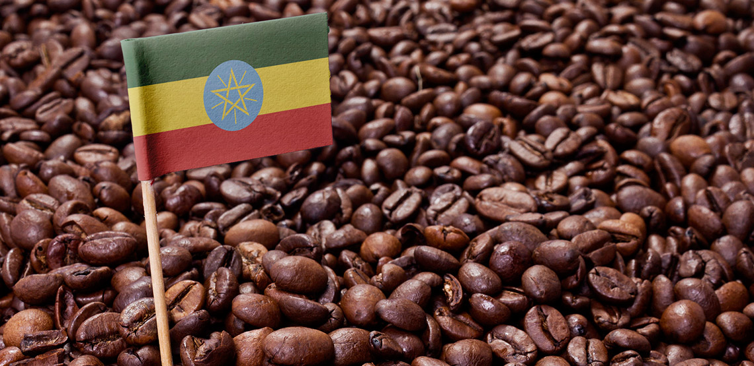
 |  |  | #501 Main Street  Calmar, Alberta  Canada, T5C 0J5  WWW.CanadianHabeshaCoffee.com | 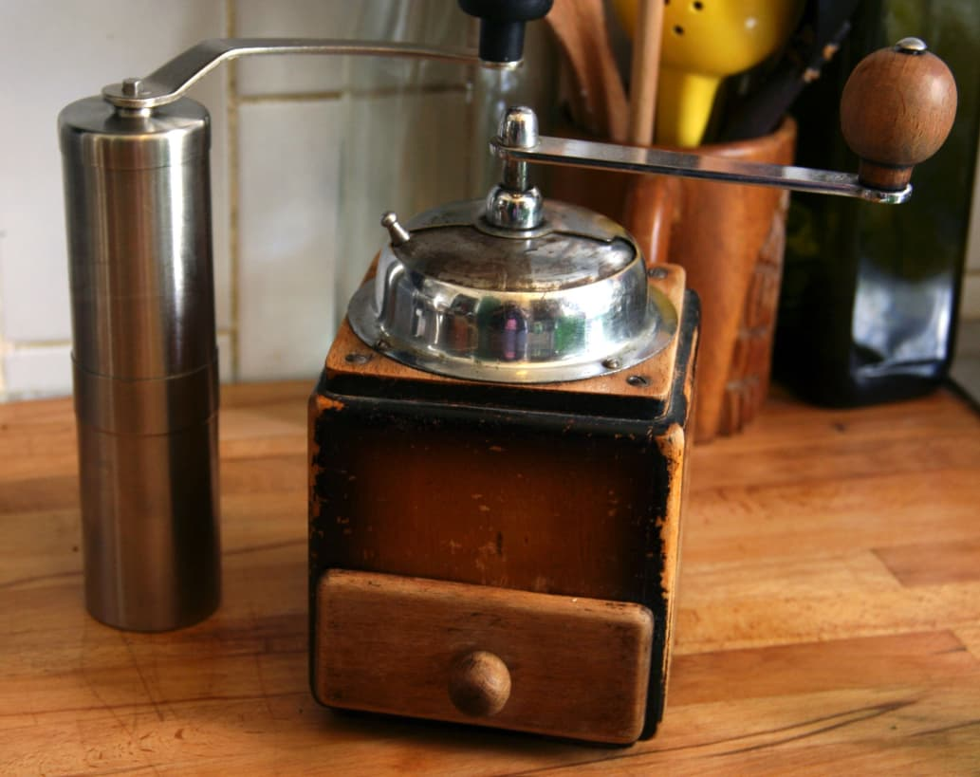
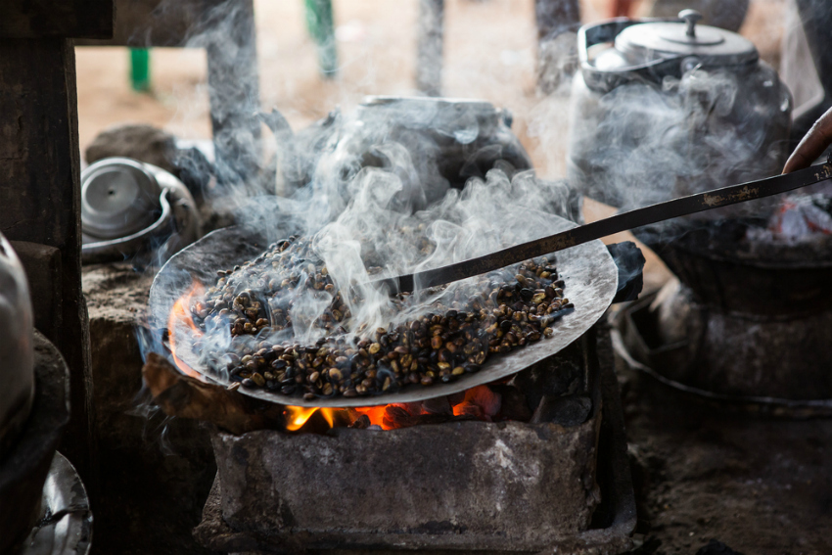
 | 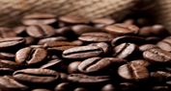  Our coffee, your way.  Each of our coffee blends can be ground to your liking. We can also provide you your choice of roast.  We can also package your coffee into your choice of K-cup, Nespresso Pod, drip coffee bag for private or commercial brewers, and we also offer single serving coffee bags.  All our coffee is packaged in vacuum sealed packaging to ensure freshness. Each roast is labeled on each package so you know you are getting a fresh product. |  |  |  |  | Our price list
 |  | All | 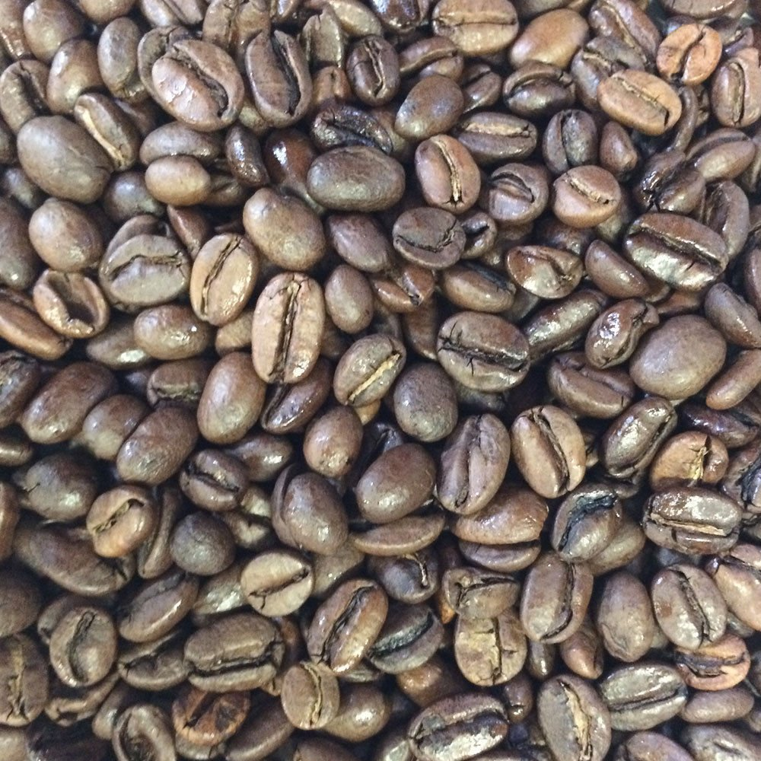 | 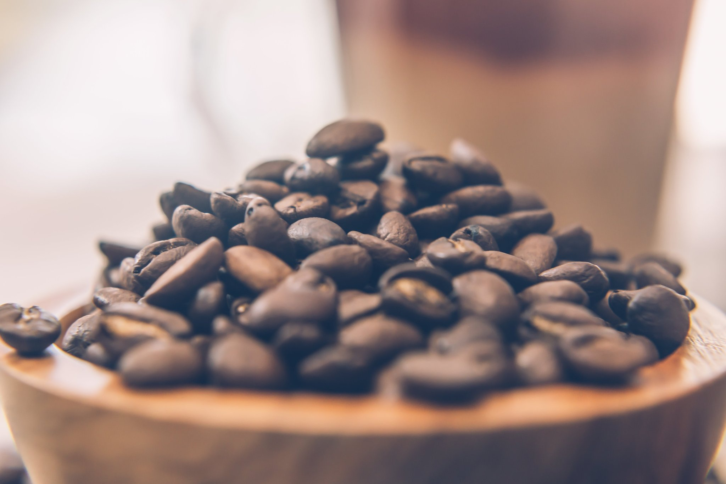
Jimma Morning Jolt  Roasted coffee per pound | $12.00
Harrar Pick-Me-Up  Roasted coffee per pound | $12.50
Yirgacheffe Special Blend  Roasted coffee per pound | $13.00
Guji Friends and Family  Roasted coffee per pound | $12.75
Jimma Morning Jolt  Raw coffee per pound | $10.00
Harrar Pick-Me-Up  Raw coffee per pound | $10.50
Yirgacheffe Special Blend  Raw coffee per pound | $11.00
Guji Friends and Family  Raw coffee per pound | $10.75
K-cup/Nespresso Pod  Packaging per pound of coffee | $1.00
drip bag packaging  Packaging per pound of coffee | $0.75

 |  | All | Jimma Morning Jolt:  This bean produces a coffee that is well balanced with a medium acidity, and it has a distinct wine flavor. | Harrar Pick-Me-Up:  This bean produces a coffee that has a medium to light acidity, with a rich full bodied taste, with a strong mocha flavor and a hint of blueberry.
 |  | All | 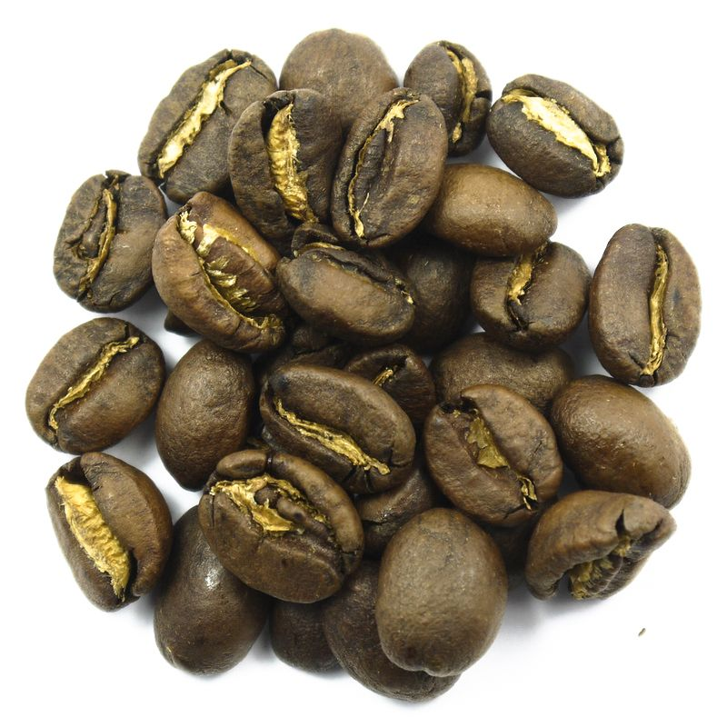 | 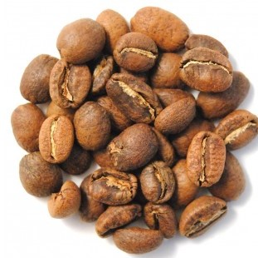
 |  | All | Yirgacheffe Special Blend:  This bright bean produces a coffee that is a bit higher in acidity than other regions, but it comes with a light body and a nice mix of sweet fruity flavors with a hint of floral notes. | Guji Friends and Family:  This bean produces a coffee with a sweet floral note, such as jasmine with melon and peach, and a tea-like body.
 |  | All | 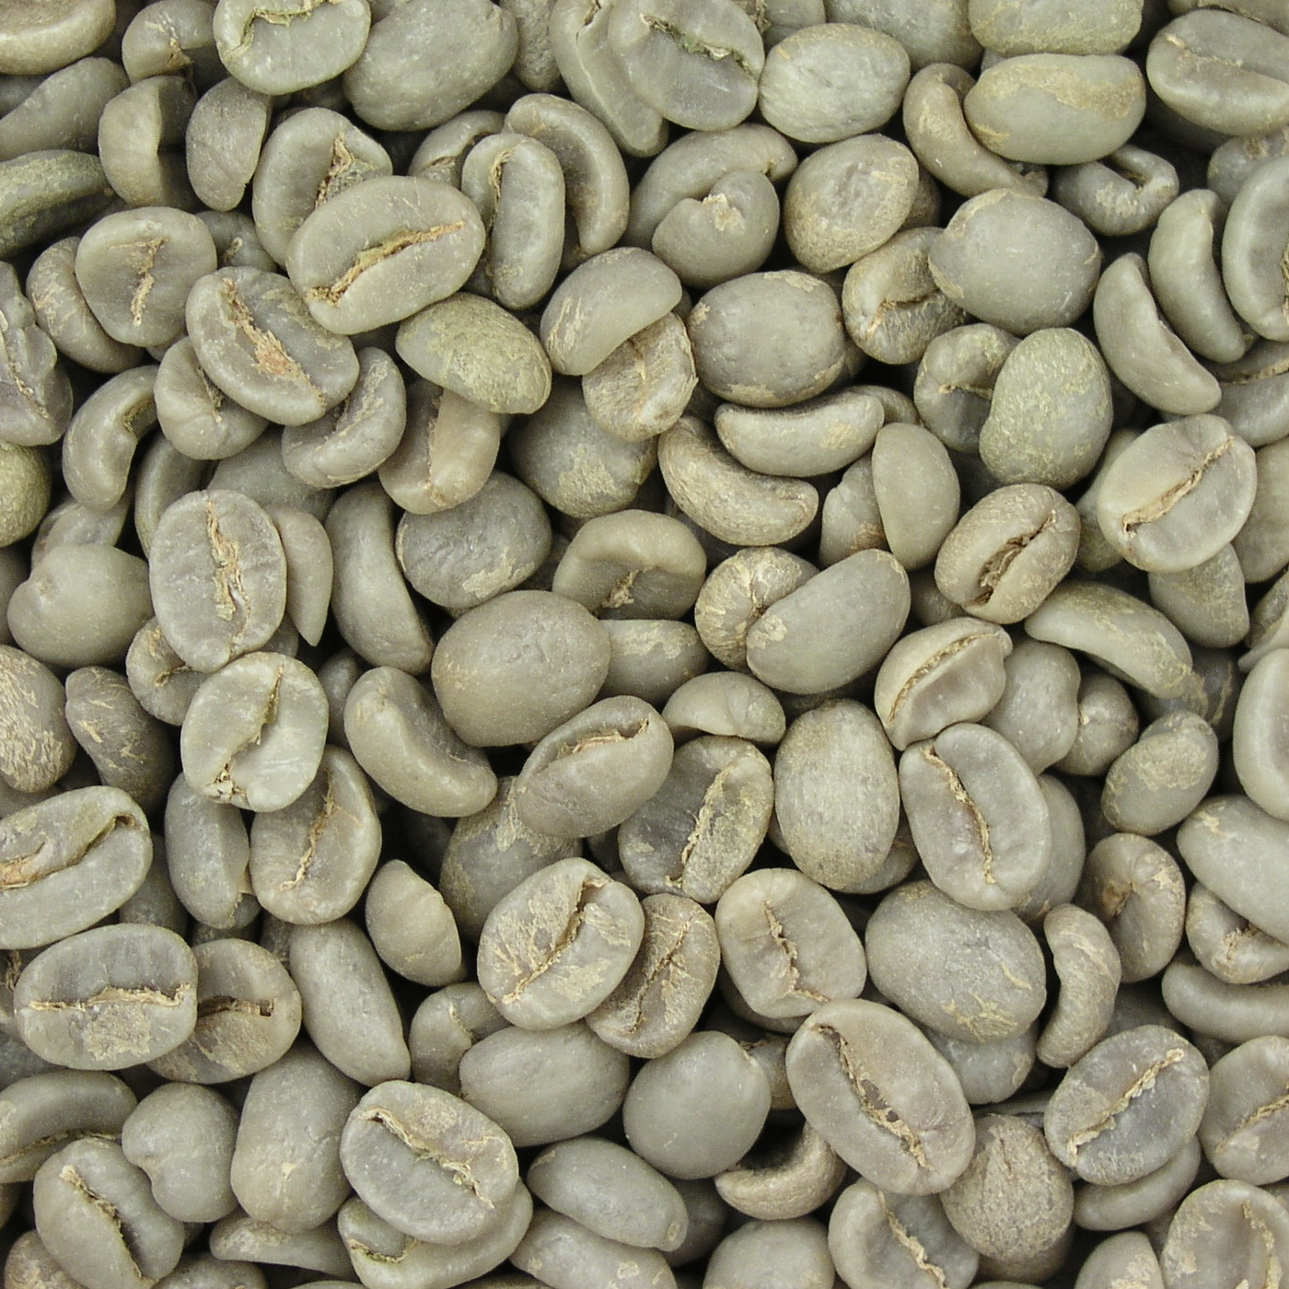 | 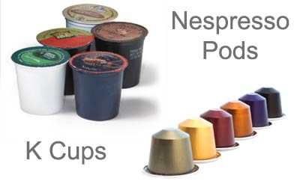
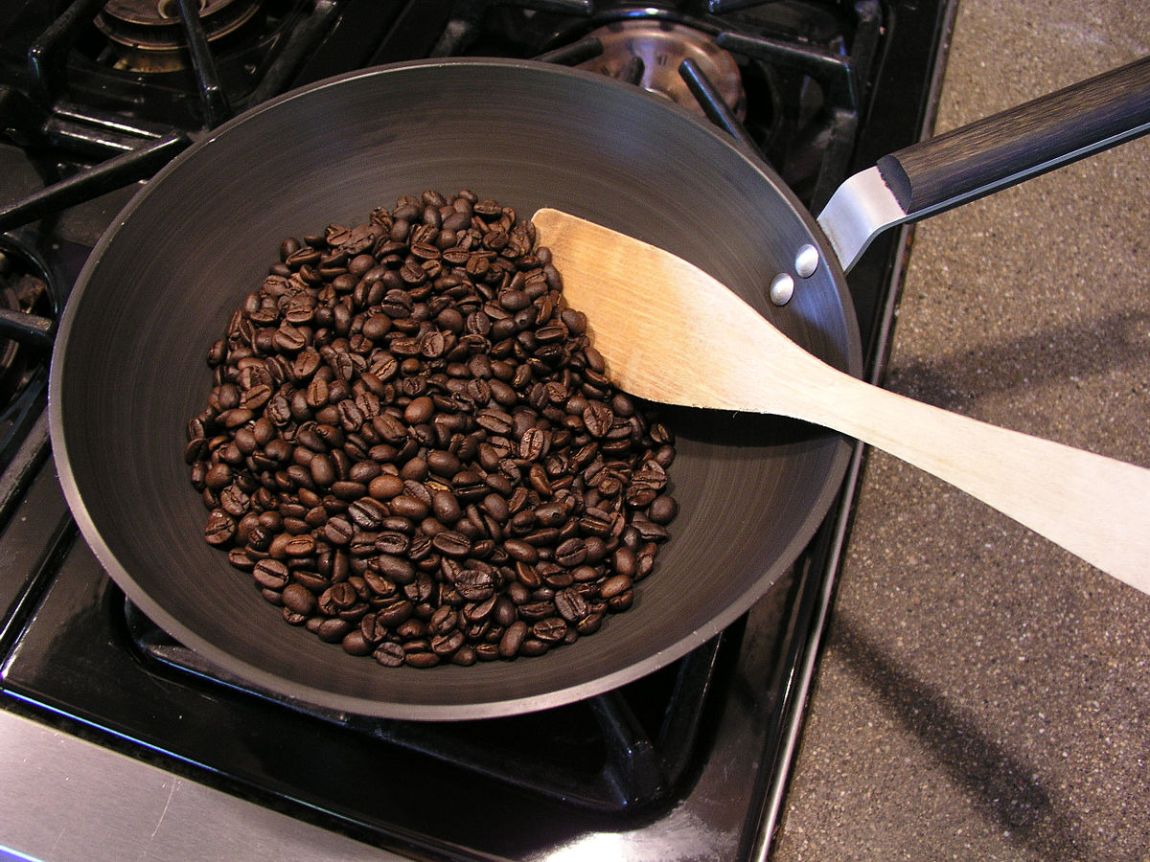
 |  |  | Raw beans can be ordered in your choice of blend and shipped to you in vacuum sealed packaging for you to roast at home. | Each of our coffee offerings can be packaged in your choice of K-cup, Nespresso Pods, or drip bags for use in home and commercial coffee brewers, or individual serving coffee bags.

